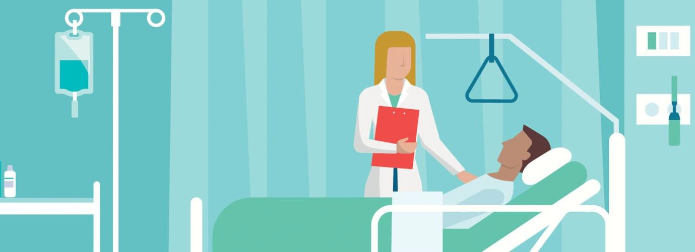

Important Information

Name of placement: Holywell Ward
Directorate: Surgical
Direct Telephone Numbers: 01246 512383 / 512384
Shift Patterns: Mornings 07:00-14:30 Afternoons 13:30-21:00
Middle Shift 11:30-19:00

Important Email addresses:

Matron
Claire Bond – clairebond2@nhs.net

Sister
Karen Stevenson – Karen.stevenson5@nhs.net

Caroline Wilson – cwilson31@nhs.net

Jeniffa Swann – jeniffaswann@nhs.net

Learning Environment Managers (LEM)
Shelley Butler – shelleybutler1@nhs.net

Jeniffa Swann – jeniffaswann@nhs.net

Holywell Ward Staff

Matron
Claire Bond
Sister
Karen Stevenson

Caroline Wilson

Jeniffa Swann
Staff Nurses
Shelley Butler Bonnie Richards
Natalie Garnett Katie Dring
Nicky Payne Fiona Bralsford
Rachel Marklew Lorraine Brooks
John Walker Diana Booth
Rebecca Hammill Kathryn Hazlehurst

Health Care Assistants
Denise Wilkes Sarah Bradshaw
Lois Stirland Raine Lee
Kay Fenwick Donna Rawson
House Keeper Receptionist
Julie Frost Louise Nicholson
Sharn Jones Rachel Elliott

Holywell Ward Link Nurses

Name | Link/Role
Shelley Butler Jeniffa Swann | Learning Environment Manager  (LEM)
Natalie Garnett | Pressure Ulcer Prevention Champion
Donna Rawson | Key Movers
Bonnie Richards | Infection Control Champions
Lois Stirland | Dementia Champion
Nicky Payne | Health Promotion  Drug and Alcohol Liasion
Lois Stirland | Privacy and Dignity & Learning Disability Champions
Rachel Marklew | Blood Glucose and Pregnancy Machine Monitor
 | Autism Champion

Holywell Day Surgery Suite Philosophy of Care

The staff in the day surgery suite are highly motivated individuals who will endeavor to support students and learners whilst respecting the patient’s dignity and individual needs at all times.

Staff will keep the patient up to date with their care on the day of surgery and ensure that all relevant information is given to the patient prior to their discharge home or transfer to another inpatient ward.

What We Expect From Students

 To be punctual, honest and reliable.
 To be dressed appropriately as per hospital dress code.
 To treat all patients with dignity and respect.
 To treat all patients in a non-discriminative manner respecting their individual beliefs.
 To become a valued member of the team.
 To maintain patient confidentiality.
 To participate and promote health and safety whilst in the workplace.
 To become actively involved in reporting incidents using the designated electronic system whenever required to do so.
 To provide a high standard of holistic care considering the patients physical, psychological, emotional and spiritual needs.
Be responsible for identifying learning opportunities and strive to make the most of these.
 To research and read around key elements related to day surgery (see suggested list of key areas to read about in preparation for your placement and throughout).

Procedures that you may be involved in and patients you may care for on Holywell Day Unit

Ophthalmic surgery

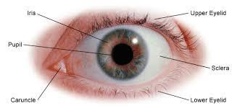

- Phacoemulsification and Ozurdex Injection
- Plastic surgery of the eye area

ENT and Maxillofacial surgery
- Grommet insertion
- 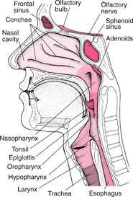Septoplasty
- Sub-Mucosal diathermy
- Nasal polypectomy
- FESS-Functional endoscopic sinus surgery
- Coloblation and Paltoplasty
- Teeth extraction
- Oesophagoscopy
- Oesophageal Dilation
- Laryngoscopy
- Tonsillectomy

Orthopaedic Surgery
- Shoulder arthroscopy
- SLAP repair of shoulder (Superior Labrum Anterior to Posterior)
- Carpel Tunnel
- Cubital Tunnel elbow
- 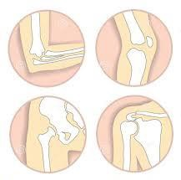Trapezectomy
- Dupytrons Contractor
- Removal of Ganglions (hands and feet)
- Knee Arthroscopy
- Anterior Cruciate Ligament repair
- Manipulation of knee
- Chondroplasty
- Ankle arthroscopy
- Removal of metalwork from limbs
- Bunion repair
- Toe amputation
- Toe straightening
- Toe Nail removal

Pain Management
- Facet Joint/Sacroiliac Joint injections
- Nerve root injections
- Epidurals
- Amantadine infusions
- Diagnostic Modal Branch injection
- Radiofrequency ablation neurotomy

General Surgery

Vascular
- Angiogram
- Varicose Vein Stripping
- Vena Cava filter removal

Breast Surgery
  - Sentinel Node biopsy
  - Wide local excision
  - Mastectomy
  - Nipple reconstruction
  - 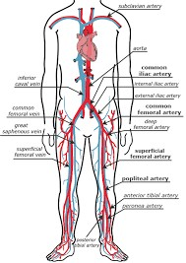Lipomodelling

Urology

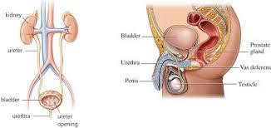

- Insertion of a suprapubic catheter
- Vasectomy
- Circumcision
- Testicular embulisation
- Nesbit’s Procedure
- Trans Vaginal Tape
- Frenuloplasty
- Trans Urethral Resection of Tumour
- Ureteroscopy
- Cystoscopy
- Cystodilatation

Colorectal
- 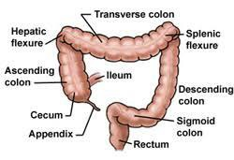Inguinal Hernia repairs
- Haemorrhoidectomy
- Botox
- Laying open of Fistula
- Skin tag removal

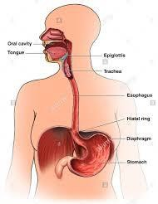Upper GI
- Laparoscopic Cholecystectomy
- Umbilical Hernia repair

Procedures that can be requested by any speciality
- Hip aspiration and biopsy
- Trial without catheter
- Blood transfusion
- Amantadine infusions
- Lung and Liver biopsy
- Iron infusion
- Joint injections

General Abbreviations

OPA/OPD Outpatients appointment/Department
ROS Removal of Sutures
DN District Nurses
NFU No follow up
PON&V Post op nausea and vomiting
STOP Surgical termination of Pregnancy
IVI Intravenous infusion
IM Intra-Muscular injection
SC Subcutaneous Injection
PO Oral
PV Per Vagina
PR Per Rectum
PU’d Passed Urine
OPU’d Not passed Urine
CSM Colour, sensation and Movement
TTO Tablet to take home
CVA Cerebral Vascular Accident (stroke)
TIA Trans Ischemic Attack (Mini Stroke)
MI Myocardial Infarction
LMP Last menstrual period
BP Blood pressure
RR Respiratory rate
TPR Temperature, pule and respirations
P Pulse
CPR Cardio Pulmonary resuscitation
PACU Post Anaesthetic Care Unit (recovery)
O2 Oxygen
SATS Oxygen saturations
NWB Non-weight bears
FWB Full weight bears
PWB Partial weight bears
MED 3 Fitness for work form/Sick note
EUA Examination under anaesthetic

IDDM Insulin dependent Diabetic
NIDDM Non-Insulin dependent Diabetic
WLR Waiting list repeat
RC Routine clinic
ROM Range of movement
DVT Deep vein thrombosis
VTE Venous Thromboembolism
WLE Wide local excision
SNB Sentinel Node biopsy
VV Varicose Veins
CTR Carpal Tunnel repair
LIH Left Inguinal Hernia repair
RIH Right Inguinal Hernia repair
TURT Trans Urethral Resection Tumour
PHARCO Phacoemulsification (Cataract surgery)
EPI Epidural
CIRC Circumcision
VAS Vasectomy
TWOC Trial without catheter
FESS Functional Endoscopic Sinus surgery
GA General Anaesthetic
LA Local Anaesthetic
SED Sedation
NEWS National Early Warning Score

If there are any more you come across, then please list them below: -

Opportunities

During your placement we will endeavor to offer you the following:
-Support you in prioritizing and managing a group of patients care from admission to discharge.
-We will arrange for you to work within our cataract theatre and care for patients and observe different types of eye surgery.
-Support you to become competent and confident in completing the necessary documentation specific to day surgery.
-To become aware of both pre and post op complications.
-Learn to recover patients from different types of anaesthetic including, general anaesthetic, local anaesthetic, spinals.
-Follow a patient through from admission to discharge observing their operation in main theatres.
-Become competent in using the bleep system.

Suggested Reading Material

Benefits of Day Surgery Nurse Led Discharge Criteria
Different types of anaesthetics Pre-operative starvation
Pain Management Premedication Drugs
Consciousness/Emesis and Pain assessment scale Postoperative complications
Common types of Day Surgical Procedures Consent to treatment Marking Verification

Evaluation of Mentorship - Holywell Ward

Holywell ward staff regard supporting students as an extremely important role for both the students and the nurses future practice and development. As well as students being required to meet their learning outcomes to progress throughout their course, it is also vital that mentors are also monitored and reviewed regularly to be deemed fit for mentoring in clinical practice. As a result of this, students are asked if they would produce an evaluation of their mentor's performance throughout their placement. This evaluation will be clear and concise, and will be set out to meet their triennial review criteria. It is requested that your comments be honest and constructive criticism is welcomed. In doing this, it will enable us as a ward and learning environment to identify areas for development and improvement for future students.

Evaluation of Mentorship Holywell Ward

Name of mentor………………………………………………………………

A welcome letter and pack was received prior, or during your first week of placement. | Yes | No | NMC STANDARDS 1, 2, 5
Were you shown how to access the ward policies and resources? |  |  | NMC STANDARDS 1,2,3,4,5,6,7,8
Were you asked about your previous experience, knowledge and skills? |  |  | NMC STANDARDS 1,2 8
Were you provided with relevant opportunities to meet your learning outcomes? |  |  | NMC STANDARDS 1,2,3,4,8
Did you receive your supernumerary status within practice and was this maintained? |  |  | NMC STANDARDS 2,5,8
Were your questions welcomed and appropriate answers given? |  |  | NMC STANDARDS 1,6,7,8
Were you welcomed and respected as a team member whilst on your placement? |  |  | NMC STANDARDS 1,2,3,5,7
Did you receive your interviews at the appropriate times? |  |  | NMC STANDARDS 1,2,3
Did you receive regular feedback either written/verbal on your personal progress from your mentor? |  |  | NMC STANDARDS 1,3,4,5,8

Did your mentor demonstrate a knowledge and understanding of the university documentation? | Yes | No | NMC STANDARDS 1,2
Was your off duty designed to reflect your mentors working pattern, adhering to the minimum 40% of time on your placement. |  |  | NMC STANDARDS 1,2,3
Were you given the opportunity to participate in teaching/supporting others in practice? |  |  | NMC STANDARDS 1,2,5,6,8
Did your mentor encourage you to ask questions and rationalize your answers? |  |  | NMC STANDARDS 1,6,7,8
Overall, did you feel well supported by your mentor for the duration of your placement? |  |  | NMC STANDARDS 1,2,3,5,7,8

Overall Comments

Thank you for your support and feedback. Please give this completed evaluation to the LEM.

