Macmillan Cancer Information and Support Centre
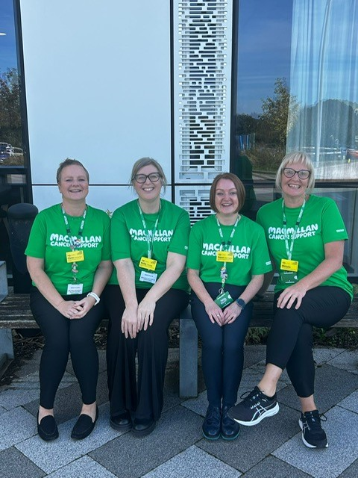
Cancer information has developed over recent decades and ensuring people affected by cancer have access to up to date information and support is an integral part of cancer care. The Macmillan Cancer Information and Support Centre is based in the NGS Macmillan Unit at Chesterfield Royal Hospital and offers information and support to anyone affected by cancer. The centre is staffed by a Macmillan Information and Support Centre Lead Nurse, two Macmillan Information and Support Nurses, Macmillan Information and Support Assistant and a small team of volunteers. Patients and families are able to drop into the centre to meet the staff and volunteers who will help people find the information and support needed. The centre hold directories of both local and national information and works closely with the clinical specialist teams across Derbyshire and South Yorkshire.
Anyone affected by cancer can arrange an individual 1:1 session. Holistic needs assessments may be completed within the centre with people signposted to appropriate support and information. Services are free and include a Look Good Feel Better service, a Wig fitting service (there is an NHS prescription cost), Headstrong service (scarf and hat advice if you are facing hair loss), Psychology service and Welfare and benefits service, all of which people can book through the centre.
During your time in the NGS Unit you will be able to spend time in the centre and learn more about the process of cancer information and the nursing role in researching, writing and provision to people affected by cancer.

