DEVONSHIRE WARD STUDENT HANDBOOK. GENERAL SURGERY
LEM:- LEANNE JONES
Email- leanne.jones7@nhs.net

Welcome to Devonshire ward- Devonshire is a ward specialising in general surgery, we see a variety of different conditions on the ward. Please take time to look at your handover sheet and identify learning opportunities that you might like to observe and participate in. Any issues, please contact me ASAP and we can discuss these.

What is expected of you the student-
Treat all staff and patients using the 6C’s in nursing-
• Care
• Compassion
• Communication
• Competence
• Courage
• Commitment
On the first day of placement introduce yourself to your supervisor and assessor-
- State what year you are in and ask for their NHS Email address.
- You are in control of your own learning- Tell the member of staff you are working with what you want to achieve on that shift, e.g., any procedures that you want to observe or proficiencies that you need to cover- be proactive.
- Look at your handover sheet and highlight anything you don’t understand or want to know more about.
- Medication rounds are very important but so is basic patient care. This is not a health care role, but an essential part of a patient assessment. Please do not think that you are being used as an HCA because you are asked to wash a patient.
- Observations are part of nursing and identify a deteriorating patient, this is not just an HCA job.
- Learn about commonly used medications within surgery- Antiemetic, analgesics, antibiotics and anti-coagulants.
- If you don’t know what a medication is used for, at least know where to look- BNF or MEDUSA for injectable medications. You are not expected to know every drug, but “I don’t know”, is not an acceptable answer.
- Due to ward acuity; you may not always be able to participate in all medication rounds. When you do, please remember the 5 rights of Medication administration- RIGHT PERSON, RIGHT DRUG, RIGHT TIME, RIGHT ROUTE, RIGHT DOSE, and a patient right to refuse.
- 3rd year student, take care of your own bay of patients; do not leave this until your management placement.
- Familiarise yourself with documentation used on the ward- Care plans, risk assessments, fluid balance charts, stool chart.
- Through your placement choose a few surgical conditions that you are interested in and investigate them in more depth. Look at the signs and symptoms of the condition, diagnostic test, treatment/ surgical plans, post-operative management and discharge requirements.
- Please adhere to the correct dress code.
- Breaks should be taken at the same time as the nurse leading your team unless told otherwise.
- If you need to change a shift or leave early, please see the nurse in charge, one of the ward sisters or an L.E.M.
- You are part of the Devonshire team whilst on placement and your contribution is valued.
- Your L.E.M is Leanne Jones.

Members of the multidisciplinary team (MDT)
- Matron
- Doctors
- Sisters
- Nurses
- Health care assistants (HCA)
- Nursing associates (NA)
- Occupational therapists (OT)
- Physiotherapists (PT)
- Speech and language therapists (SALT)
- Stoma team
- Breast team
- Palliative care team
- House keepers
- Domestics
- Patient service assistant (PSA)
- Receptionist
- Pharmacist
- Tissue viability nurse (TVN)
- Upper G.I nurses

Devonshire Ward is a general surgical ward based at Chesterfield Royal Hospital. We diagnose and treat multiple conditions and specialities. These specialities are as following: -
- Upper GI
- Colorectal
- ENT/ max fax
- Gynae
- Breast
- Urology
- Vascular

Common diagnostics test for surgery include-
- X-ray
An X-ray is a quick and painless procedure commonly used to produce images of the inside of the body.
- USS- Ultrasound scan
An ultrasound scan, sometimes called a sonogram, is a procedure that uses high-frequency sound waves to create an image of part of the inside of the body. An ultrasound scan can be used to monitor an unborn baby, diagnose a condition, or guide a surgeon during certain procedures.
- MRCP
A magnetic resonance cholangiopancreatography (MRCP) scan is a non-invasive medical scanning method that uses radio waves and a magnetic field
- ERCP
Endoscopic retrograde cholangiopancreatography (ERCP) is a procedure that combines upper gastrointestinal (GI) endoscopy and x-rays to treat problems of the bile and pancreatic ducts.
- MRI
Magnetic resonance imaging (MRI) is a type of scan that uses strong magnetic fields and radio waves to produce detailed images of the inside of the body.
- CT
A computerised tomography (CT) scan uses X-rays and a computer to create detailed images of the inside of the body.
- Blood tests
- Sputum samples
- Urinalysis

The gastrointestinal tract (G.I)
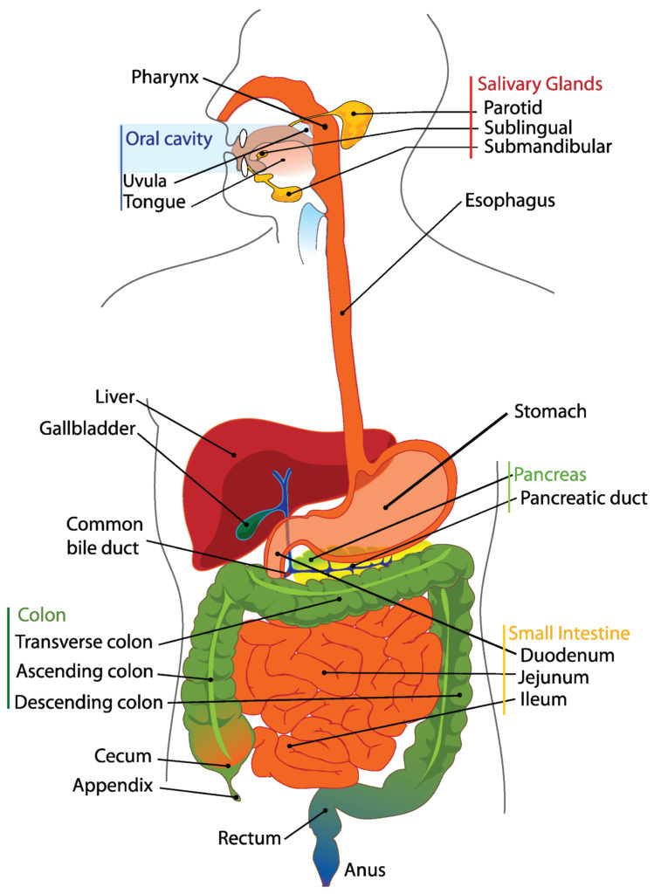
Upper gastrointestinal (GI) surgery is surgery performed to treat pathologies of the oesophagus, stomach, pancreas, liver, spleen, bile duct and gall bladder.
The upper gastrointestinal (GI) includes the oesophagus (the food pipe), the duodenum (the first part of the small intestine) and stomach.
A doctor might recommend upper gastrointestinal (GI) surgery if a patient suffers from symptoms including bloating, abdominal pain, heart burn, swallowing difficulties and acid regurgitation. The condition is first evaluated using diagnostic techniques to find the underlying conditions. Symptoms that may motivate someone to see a doctor are as follows: -
- Pain and inflammation of the stomach and flank area.
- Gastritis.
- H-pylori infection.
- Gastroesophageal reflux disease (GORD)
- Peptic ulcers (sores)
Common upper GI procedures include: -
- Laparoscopic cholecystectomy (removal of the gall bladder)
- Laparoscopic cholecystectomy and bile duct exploration
- Endoscopic Retrograde Cholangiopancreatography (ERCP)
- Laparoscopic repair of hiatus hernias
- Gastroscopy +/- oesophageal stent insertion
- Laparoscopic repair of inguinal hernias
- Laparoscopic repair of incisional hernias
- Open repair of inguinal hernias (under local or general anaesthetic)
- Repair of para-umbilical, femoral and epigastric hernias
- Laparoscopic staging of tumours
Colorectal surgery: - specialises in the diagnosis and treatment of colorectal and anal pathology including bowel cancer (colorectal cancer), diverticular disease and inflammatory bowel disease (ulcerative colitis and Crohn’s disease).
Some of the signs that may make people seek advice from a doctor are as follows: -
- Fatigue
- Cramping
- Bloating
- Gas
- Diarrhoea
- Constipation
- Abdominal pain
- Some of the conditions that may require colorectal surgery are as follows: -
- Colorectal cancer
- Ulcerative colitis
- Crohn's disease, and some cases of diverticulitis
- Haemorrhoids
- Anal fissures (tears in the lining of the anus)
- Rectal prolapse

Max fax/ ENT
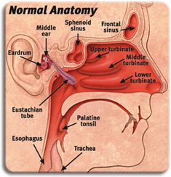
What do ENT specialists do?
The ENT team treat conditions that affect the senses such as hearing and balance disorders or smell and taste problems. You'll also treat patients with conditions that affect their voice, breathing and swallowing as well as those with head and neck tumours.
Types of common ENT surgeries-
Otology – Treatment of infection, disease and damage to the ear to improve hearing and balance. Neurotologists deal with conditions deep in the middle and inner ear where conditions are more closely linked to the brain.
Rhinology – Treatment of sinus and nasal disorders, including allergy, to relieve pain, ease breathing and improve nasal function.
Laryngology – Treatment of infections of the throat and larynx to ease speech and swallowing.
Head and neck surgery – away from the main ENT systems, specializing in surgery on cysts, glands such as lymph, salivary, thyroid and parathyroid glands, and head and neck cancers.
Facial plastics – this can include aesthetic procedures such as rhinoplasty (‘nose job’), pinnaplasty (bat ears), face lifts or reconstructive such as re-setting the jaw. There is a big cross-over here with the work of plastic and oral and maxillofacial surgeons.
Paediatrics – there are many ENT conditions, often congenital, that require treatment at a very young age. These include airway problems, infections of adenoids or tonsils that require their removal, and grommets for ‘glue ear’.
Insertion of grommets - to allow air to middle ear in cases of chronic middle ear infection to assist hearing. This is typically carried out in children and removed when infection clears.
Tonsillectomy - removal of tonsils and/or adenoids to relieve a variety of conditions.
Septoplasty - correction of nasal septum to enable clear breathing and prevent obstruction.
Endoscopic sinus surgery - minimally invasive surgery for serious cases of inflamed, infected and blocked sinuses.
Tracheostomy or “operations on the voice box (larynx)” - creation of an alternative airway in the throat for patients having trouble breathing.
What do Maxillofacial (Max Fax) surgeons do?
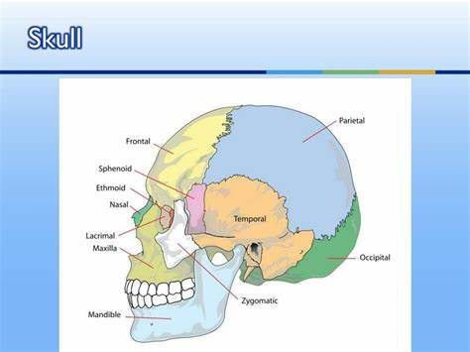
Maxillofacial surgeons, sometimes called oral and maxillofacial surgeons, are trained to handle a wide variety of conditions and injuries that affect the head, neck, mouth, jaw, and face. Types of common max fax surgeries-
- Misaligned jaws
- Impacted wisdom teeth
- Oral reconstructive surgery
- Cancers of the head and neck
- Dental implants

Gynaecology.
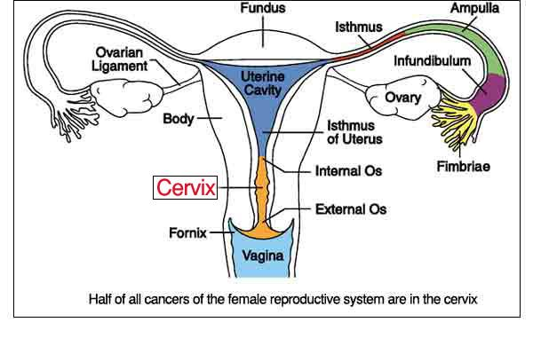
Gynaecological surgery refers to surgery on the female reproductive system usually performed by gynaecologists. It includes procedures for benign conditions also; cancer, infertility, and incontinence here are many reasons why a woman might need to undergo gynaecology surgery. She may need treatment for a condition such as endometriosis, fibroids (benign tumours), ovarian cysts, cancer, chronic pelvic pain, pelvic inflammatory disease, uterine prolapse or abnormal bleeding.
Types of surgery commonly performed-
- Laparoscopy and hysteroscopy- laparoscopy is used to examine the abdomen to investigate pelvic pain. Hysteroscopy is used to examine the uterus.
- Dilatation and curettage (D&C)- to investigate heavy or irregular periods, or to remove retained products of conception post miscarriage.
- Hysterectomy- A total hysterectomy involves the removal of the uterus and the cervix. Sub-total hysterectomy involves the removal of the uterus only. Salpingo-oophrectomy
- Endometrial ablation
- Salpingectomy- removal of the full or part of the fallopian tube
- Lap adhesiolysis- To remove scar tissue from disease or previous surgeries.

Urology
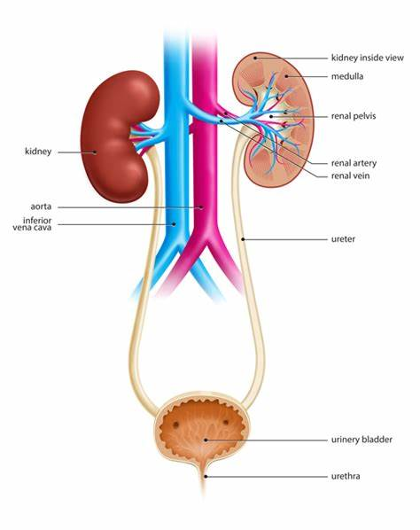
Urology is a surgical specialty which deals with diseases of the urinary/reproductive tracts in men and with urinary disease in women.
The urinary tract consists of the:
- kidneys
- bladder
- ureters
- Urethra.
- The organs covered by urology include the:
- kidneys
- ureters
- urinary bladder
- urethra
Male reproductive organs (testes, epididymis, vas deferens, seminal vesicles, prostate and penis) Common types of urology surgery include-
- Endoscopic removal of the prostate (which may involve lasers)
- Robotic surgery to remove the bladder, kidney or prostate to treat cancer
- kidney stone removal/laser fragmentation of kidney and ureteric stones
- Cystoscopy
- Urostomy- formation of a stoma to divert urine into a bag
- vasectomy
- Circumcision and scrotal surgery
- Cystoscopy: a test that allows your doctor to look at the inside of the bladder and the urethra using a thin, lighted instrument called a cystoscope
- Urodynamic: a diagnostic study of pressure in the bladder that can be used in explaining and treating incontinence.

Commonly used abbreviations.
- CBD- Catheter bag drainage/ common bile duct.
- E&D- Eating and drinking.
- NBM- Nil by mouth.
- O.T- Occupational therapy.
- P.T- Physiotherapy.
- CA- Cancer.
- O2- Oxygen.
- D/C- Discharge.
- CCOT- Critical care outreach team.
- ITU- Intensive care unit.
- HDU- High dependency unit.
- DNAR- Do not attempt resuscitation.
- TWOC- Trial without catheter.
- EST- Enhanced support team.
- FF- Free fluids.
- CFF- Clear free fluids.
- IVAB- Intravenous antibiotics.
- VRII- Variable rate insulin infusion.
- HTN- Hypertension.
- VBG- Venous blood gas.
- ABG- Arterial blood gas.
- USS- ultrasound scan/
- MFFD- Medically fit for discharge.
- TPN- Total parental nutrition.
- PICC- Peripheral inserted central catheter.
- CVP- Central venous pressure line.
- PEG- Percutaneous endoscopic gastrostomy.
- RIG- Radiologically inserted gastrostomy.
- T2- Type 2 diabetic.
- T1- Type 1 diabetic.

